OFFICIAL RECOGNIZEMENT -IMA academy international – Marijnskaya

Various legal issues develop and become very interesting to discuss and study, both issues at the national and global levels. This edition of the JILS (Journal of Indonesian Legal Studies) contains various articles related to the development of current issues in legal studies. In this edition, the papers presented come from several countries, namely Indonesia, Thailand, Russia, Malaysia, and Nigeria. This edition also consist of several universities: Walailak University Thailand, Novena University Nigeria, Adekunle Ajasin University Nigeria, University of Indonesia, Sebelas Maret University Indonesia, Monash University Malaysia, Mahidol University Thailand, Muhammadiyah Malang University Indonesia, Kazan Innovation University Russia, Russian State University of Justice, and International Mariinskata Academy Russia. This edition is avalilable online since November 24, 2020 for the 5 (2) November 2020 edition.
DOI: https://doi.org/10.15294/jils.v5i2
Published: 2020-11-24

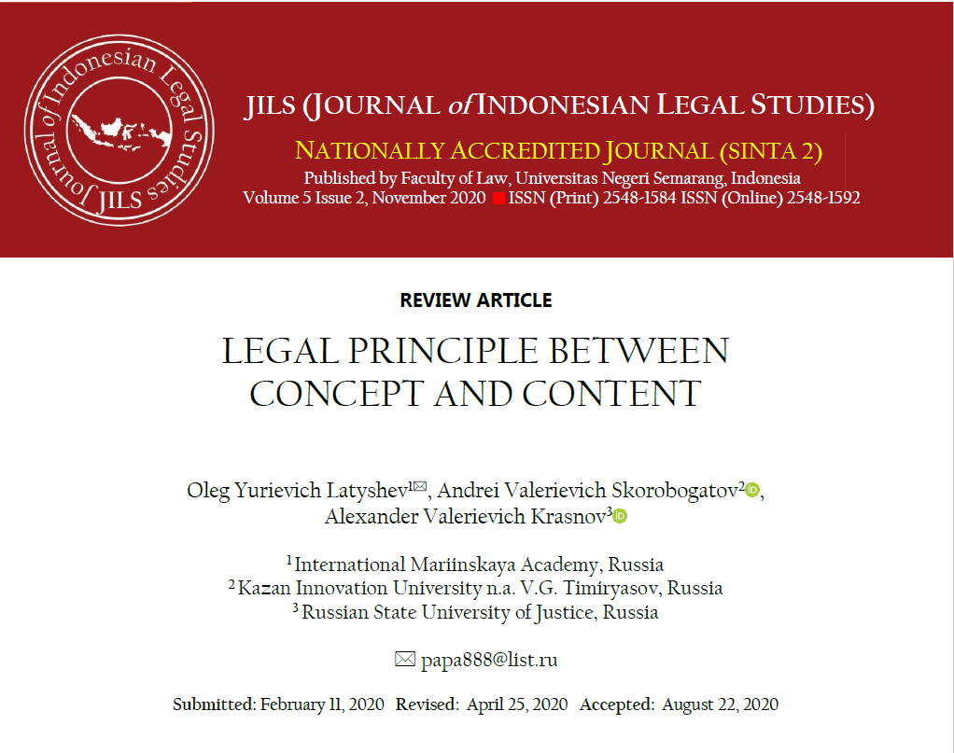

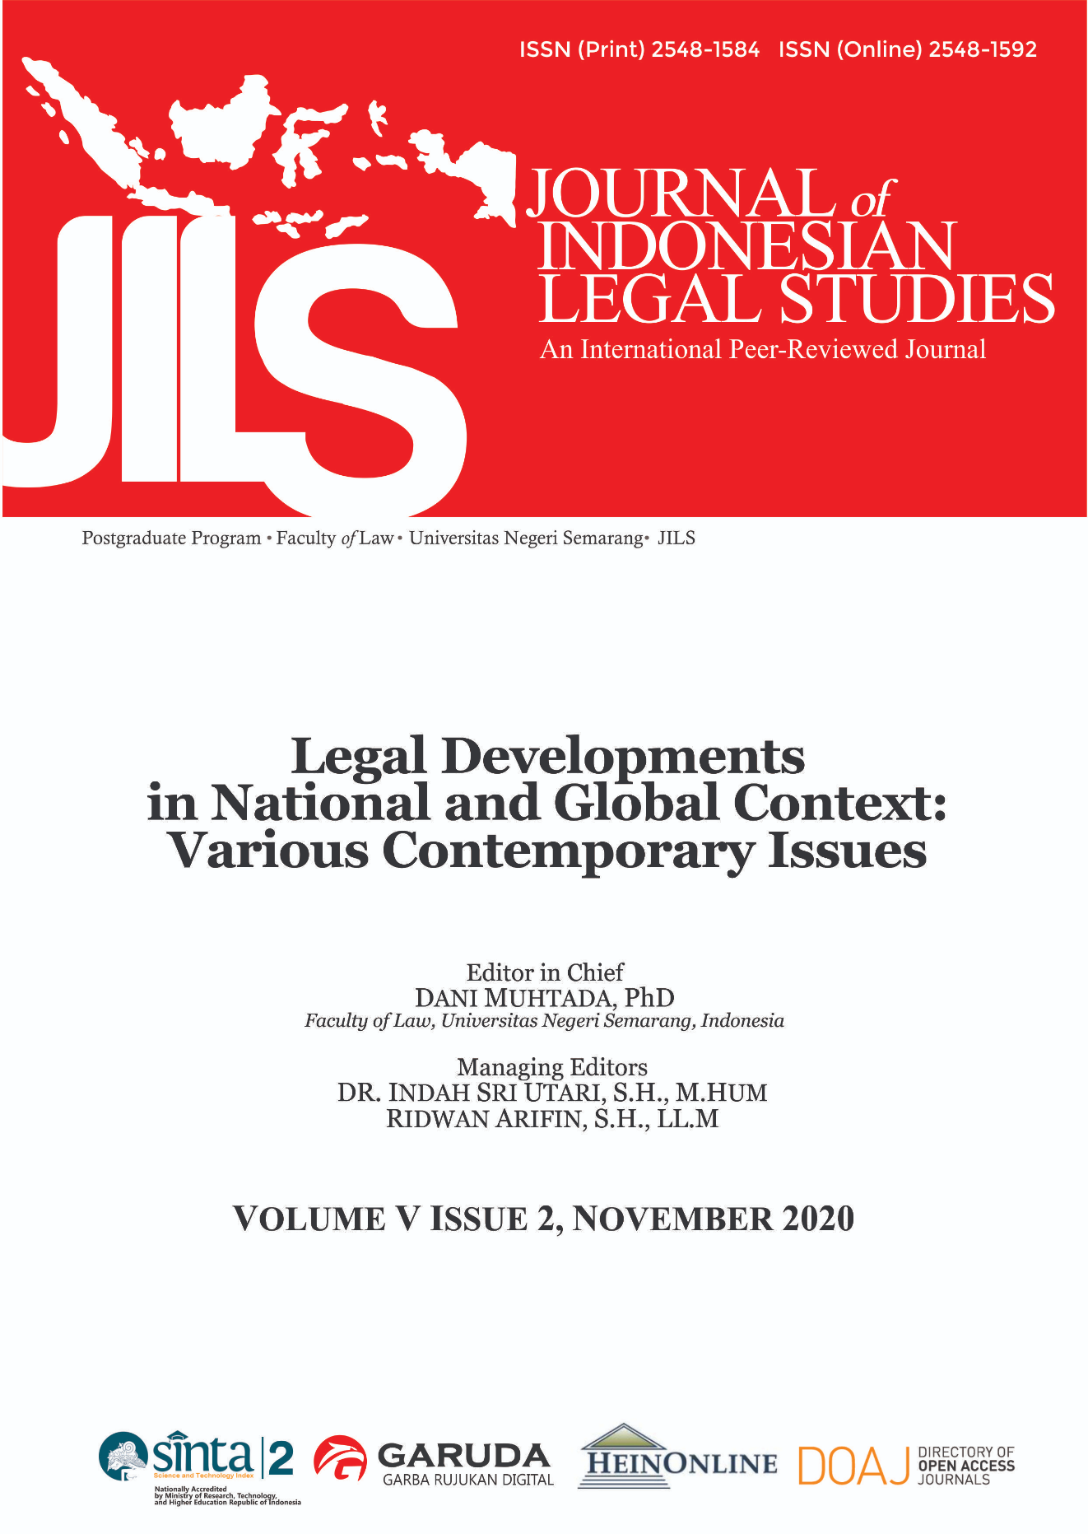

The Journal of Indonesian Legal Studies is the flagship law journal of the Faculty of Law, Universitas Negeri Semarang and one of the prominent law journals in Indonesia. As one of the leading legal journals in Indonesia, it contains a rich store of legal literature analysing the legal, political and social development of Indonesia in its progression from a developing and other nation whether First World, Second World, or Third World nation. The journal continues to advance the boundaries of global and local developments in law, policy and legal practice by publishing cogent and timely articles, legislation comments and case notes on a biannual basis.

Editorial Team 2026
Editor in Chief
RIDWAN ARIFIN, Universitas Negeri Semarang, Semarang, Indonesia
Managing Editors:
RODIYAH, Universitas Negeri Semarang, Semarang, Indonesia
DEWI SULISTIANINGSIH, Universitas Negeri Semarang, Semarang, Indonesia
SANG AYU PUTU RAHAYU, Universitas Negeri Semarang, Semarang, Indonesia
Board of Editors
SUDIJONO SASTROATMODJO, Universitas Negeri Semarang, Semarang, Indonesia
DANI MUHTADA, Universitas Negeri Semarang, Semarang, Indonesia
MARTITAH, Universitas Negeri Semarang, Semarang, Indonesia
BENNY R RIYANTO, Universitas Negeri Semarang, Semarang, Indonesia
SHRIRANG ASHTAPUTRE, ILS Law College Pune, India
FOKKE J FERNHOUT, Maastricht University, The Netherlands
TOPO SANTOSO, Universitas Indonesia, Indonesia
JHON H AYCOCK, Peking University School of Transnational Law, China
AMIR HUSN MOHD NOR, Universiti Sains Islam Malaysia, Malaysia
REID MORTENSEN, Southern Queensland University, Australia
HAJAH MAS NOORAINI BINTI H MOHIDDIN, Universiti Islam Sultan Sharif Ali, Brunei Darussalam
DEWI SULISTIANINGSIH, Universitas Negeri Semarang, Indonesia
DEWA GEDE SUDIKA MANGKU, Universitas Pendidikan Ganesha, Indonesia
NGBOAWAJI DANIEL NTE, Novena University, Nigeria
YOSHIKI KURUMIZAWA, Waseda University, Japan
ROBERT BRIAN SMITH, University of New England, Australia
ONANONG TIPPIMOL, Thammasat University, Thailand
SARU ARIFIN, University of Pecs, Hungary
STEFAN KOOS, Universitaet der Bundeswehr Munich, German
Online Editor:
YORIS ADI MARETTA, Universitas Negeri Semarang, Indonesia
KURNIAWAN, Universitas Negeri Semarang, Indonesia
Editorial Assistant
WAHYUDIN, Universitas Negeri Semarang, Indonesia
ANGGUN MEINANDA PUTRI MAHARANI, Universitas Negeri Semarang, Indonesia
Board of Administration
SRI WULANDARI, Universitas Negeri Semarang, Indonesia
RIZKY YANDA SHAGIRA, Universitas Negeri Semarang, Indonesia

